Malaria

1. **Pourcentage de patients ayant eu la fièvre au cours des 2 dernières semaines (OMS)**

**(Percentage of all patients with a fever of less than 2 weeks)**

**The numerator:** Nombre de cas fébriles <2 semaines (Number of febrile cases < 2 weeks)

Count of all patients with a fever of less than 2 weeks checked

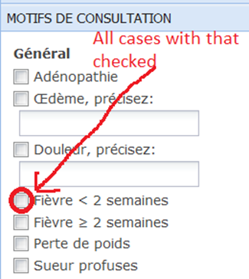

**The denominator:** number of total clinic visits for the time period. (Nombre total de visites cliniques)

Both the numerator and the denominator should be in the same time period.

1. **Pourcentage de patients avec fièvre (cas suspect) ayant reçu un antipaludique (OMS)**

**The Numerator:** Number of non-confirmed cases (use: all patients who do not fit the definition of a confirmed case) treated with either chloroquine, primaquine or quinine.(Nombre de cas suspect ayant reçu un antipaludique)

Condition 1: Non-confirmed case

Condition 2: Treated with either chloroquine, primaquine or quinine

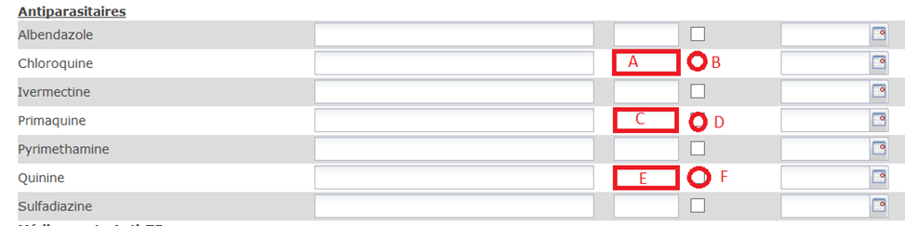

(A must not be Empty OR B must be checked) OR (C must not be Empty OR D must be checked) OR (E must not be Empty OR F must be checked)

**The Denominator:** Nombre de cas fébriles <2 semaines (Number of febrile cases < 2 weeks)

Count of all patients with a fever of less than 2 weeks checked

1. **Pourcentage de patients avec malaria confirmée ayant reçu un traitement conforme aux normes nationales du MSPP (OMS)**

**The Numerator:**  Number of confirmed cases treated with:

**Case 1:** chloroquine and primaquine (Table 2)

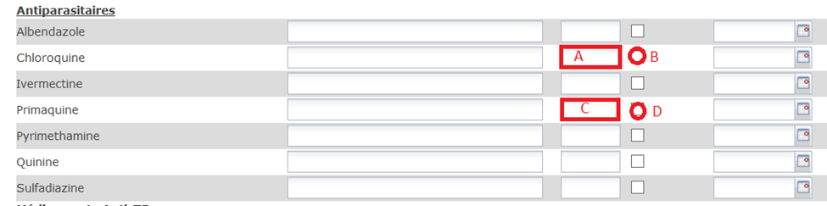

**Table 2**

(A must not be Empty OR B must be checked) AND (C must not be Empty OR D must be checked)

Or

**Case 2:** quinine and chloroquine and primaquine (Table 3)

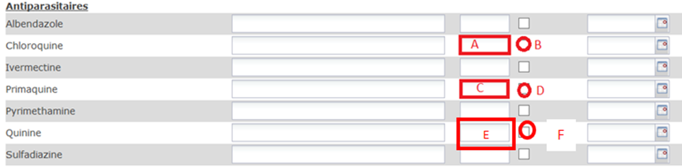

**Table 3**

(A must not be Empty OR B must be checked) AND (C must not be Empty OR D must be checked) AND (E must not be Empty OR F must be checked)

**The Denominator:** Number of confirmed cases

1. **Pourcentage de patients avec fièvre ayant été testés pour la malaria (OMS)**

Percentage of suspected cases tested

1. **The Numerator:** Nombre de cas suspects de la malaria (fièvre) dépistée (*test demande*)
   1. Number of febrile cases < 2 weeks with tests ordered for malaria (microscopy or RDT)

Condition 1: Fever < 2 weeks



Condition 2: A malaria test has to be ordered.

For OE sites:

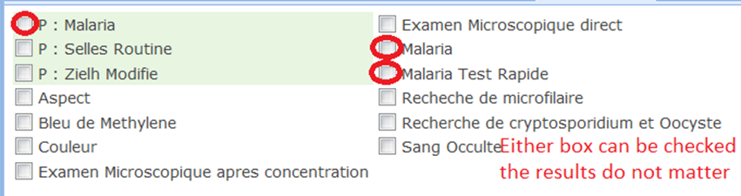

For Non OE sites:

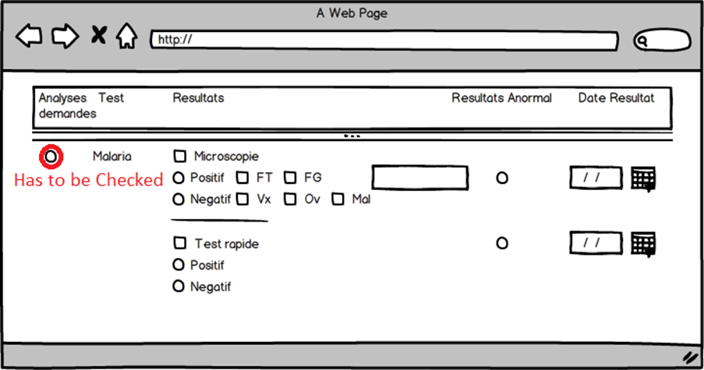

1. **The denominator:** Nombre de cas fébriles <2 semaines (Number of febrile cases < 2 weeks)

Count of all patients with a fever of less than 2 weeks checked



1. **Nombre de cas de la malaria confirmée**

**Definition:** confirmed cases

A confirmed malaria case is a patient who has:

* A clinical impression of confirmed malaria checked “Malaria (paludisme) confirmé [084]” OR
* A positive malaria test whether it is a rapid test or microscopy.

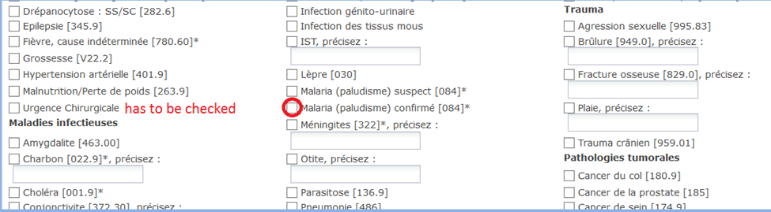

**For OE sites:**

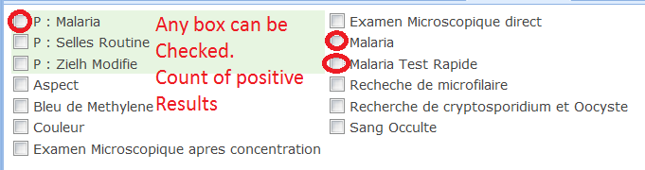

NB:

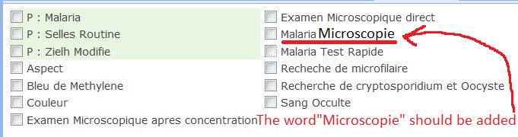

**For non OE sites:**

This is the old section to order a Malaria test for non OE sites. The old section has a confusion regarding microscopy or rapid test.

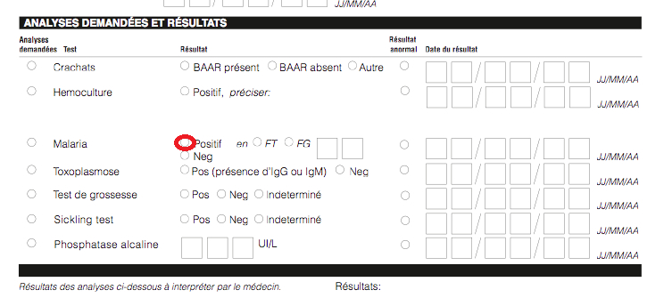

The mockup below is the new proposed section:

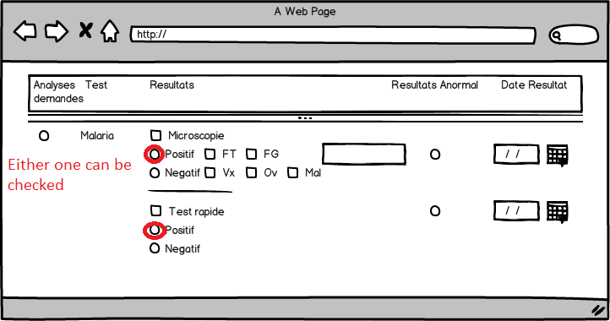

1. **Nombre de patients ayant bénéficié d’un test microscopique pour la malaria**

**Definition:** Number of patients tested with microscopy

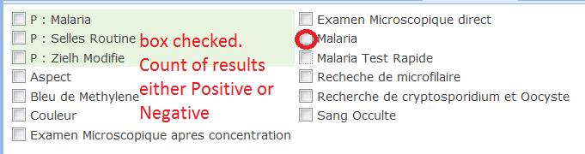

For non OE sites:

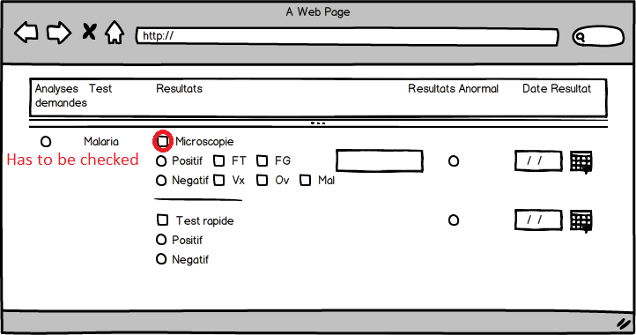

Important: for this indicator we are not counting the number of test ordered but the actual results whether they are positive or negative.

1. **Nombre de patients ayant un test microscopique positif pour la malaria**

**Definition:** count of positive microscopy results (for both OE and non OE sites)

For non OE sites:

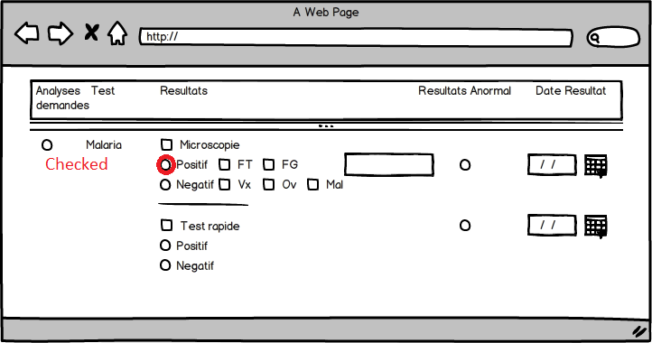

**For all microcopy results tabulate species** *Plasmodium falciparum*, *vivax malariae, ovale*, mixte

1. **Nombre de patients ayant un test microscopique positif à Plasmodium falciparum**

All patients with a positive microscopy test with plasmodium falciparum.(count should include both lab form and OE results)

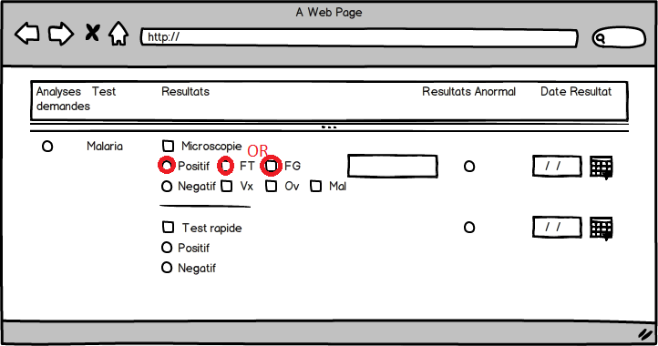

1. **Nombre de patients ayant un test microscopique positif mixte à Plasmodium (OMS)**

All patients with a positive microscopy test with plasmodium falciparum and another parasite, either Vx,Ov,Mal. (Count should include both lab form and OE results)

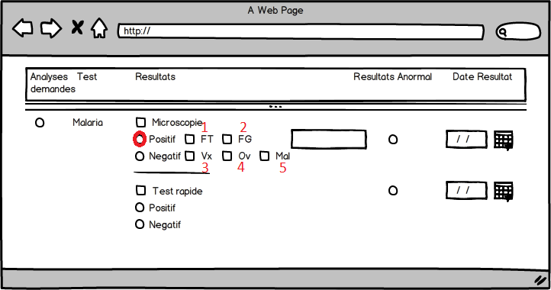

(1 And/Or 2 must be checked) AND (3 Or 4 Or 5 must be checked)

1. **Nombre de patients ayant un test microscopique positif à *Plasmodium* autres que *falciparum***

All patients with a positive microscopy test other than falciparum (Count should include both lab form and OE results)



(1 And/Or 2 must NOT be checked) AND (3 Or 4 Or 5 must be checked)

1. **Nombre de patients ayant bénéficié d’un TDR pour la malaria**

**Definition:** Number of patients tested with rapid test.

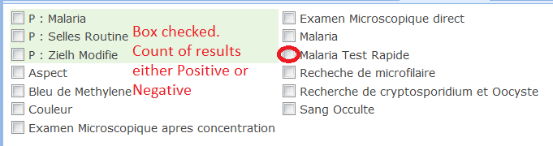

For non OE sites:

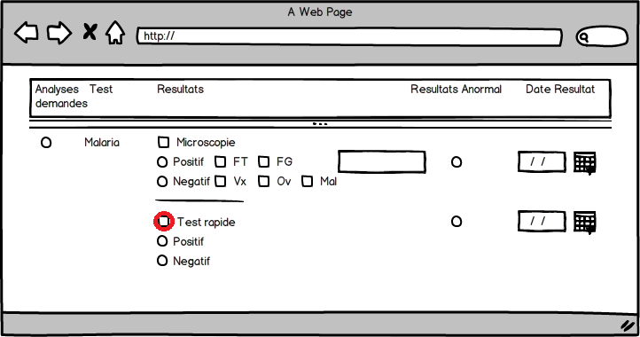

Important: for this indicator we are not counting the number of test ordered but the actual results whether they are positive or negative.

1. **Nombre de patients ayant un TDR positif pour la malaria**

**Definition:** count of positive RDT results (for both OE and non OE sites)

For non OE sites:

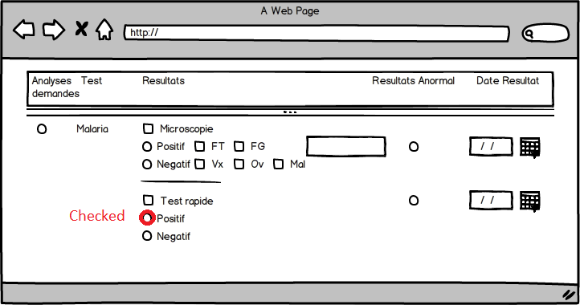

1. **Nombre de cas suspects de la malaria dépistée**

Nombre de cas suspects de la malaria (fièvre) dépistée (*test demande*)

* 1. Number of febrile cases < 2 weeks with tests ordered for malaria (microscopy or RDT)

Condition 1: Fever < 2 weeks



Condition 2: A malaria test has to be ordered.

For OE sites:

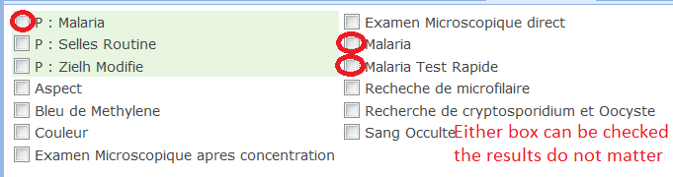

For Non OE sites:

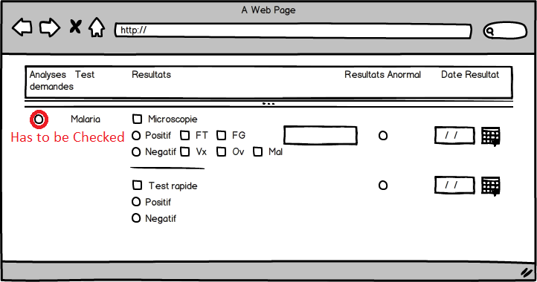

1. **Nombre de cas suspects de la malaria confirmée**
2. Number of febrile cases < 2 weeks with a positive test for malaria (microscopy or RDT)

Condition 1: Fever < 2 weeks



Condition 2: A Positive malaria test

For OE sites:



For Non OE sites:



OR



1. **Nombre de cas confirmés pour la malaria sévère et mis sous traitement selon les normes nationales du MSPP**

**Definition:** Number of confirmed cases treated with quinine + chloroquine + primaquine

Condition 1: patient must be a confirmed case

Condition 2: All must be prescribed quinine and chloroquine and primaquine at the same time

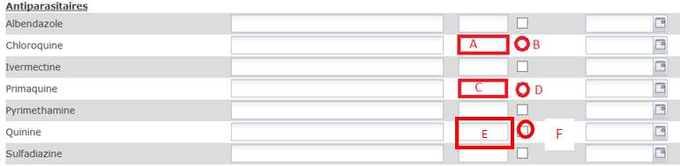

(A must not be Empty OR B must be checked) AND (C must not be Empty OR D must be checked) AND (E must not be Empty OR F must be checked)

1. **Nombre de patients avec Malaria hospitalisés**

This is basically a confirmed malaria case (indicator 5) with “Hospitalisation” Checked



1. **Nombre de patients avec Malaria décédés**

This is basically a confirmed malaria case (indicator 5) with “Decede” Checked

1. **Nombre de cas de la malaria confirmée pour les femmes enceintes**

**Definition:** Number of confirmed malaria cases for pregnant women.

Condition 1: the patient has to be a confirmed (indicator 5) case And

Condition 2: the patient has to be pregnant

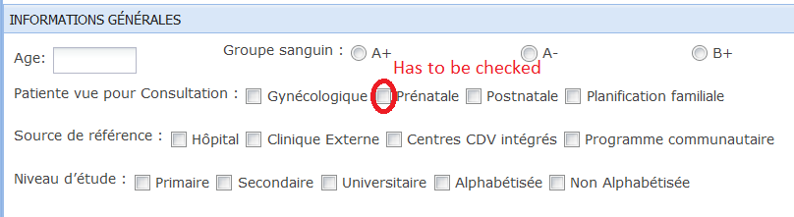

Or

